Friday 18th February 2022

Required Practical 5 – Photosynthesis

Aim

To determine the rate the effect of PH on the rate of reaction of the amylase enzyme.

Equipment

1 Boiling tube for each PH level investigated, Water bath, Buffer solutions with different PH levels, Amylase enzyme, Starch solution, Spotting tile(s), iodine solution

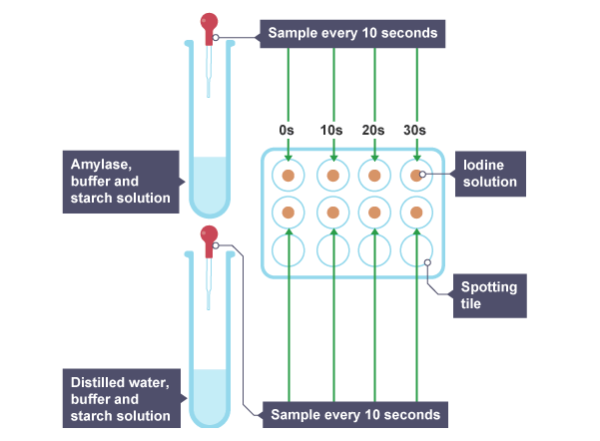

Variables

Independent Variable – PH level of the buffer solution

Dependent Variable – Time taken for starch to be broken down

Control Variables – Amount of buffer solution, starch, and amylase. Time between samples. Equal amount of iodine in wells of spotting tile.

Method

1. Place several different starch solutions with a known volume (amount) and concentration into a water bath that is not hotter than 37°C.
2. Add a buffer solution at different PH levels to each starch solution.
3. Place a drop of iodine in each well of the spotting tile.
4. Start a stopwatch and add an equal amount of amylase to each buffer solution.
5. Every 30 seconds, take a sample of each using a pipette, and add it to a well containing iodine.
6. For each PH level investigated, record the time taken for the starch to disappear (when the iodine in the spotting tile remains orange)
7. Calculate the rate of reaction for each PH level using: $Rate of Reaction=\frac{1}{time}$

Safety

Wear safety goggles, Amylase solution may cause allergic reactions, Iodine is irritant – avoid contact with skin and eyes.